**Oreoluwa Akande**

**COVID-19 in Nigeria**

At the beginning of the COVID-19 pandemic in Nigeria, three key institutions collaborated and secured an Illumina Hi-Seq device for rapid sequencing and genotyping of samples in 4 Nigerian states (Kwara, Oyo, Osun, and Ogun). Upon sequencing, they generated full-length sequences from the first 10 positive samples.

As a public health bioinformatician, you are tasked with answering some urgent questions about the epidemiology of the virus. These questions include:

* Construct a phylogenetic tree for the samples in Nigeria in comparison to samples from Italy, China, UK, and USA
* What is/are the most likely geographical sources of the samples in each state? (Italy, China, UK, or the USA).

DATASET: Here

Inference: all the samples from wuhan, Italy, UK, USA,OYOO8,KWO17,OYO45A,OG007,OSO85,OSO75,OSO70,OS122 (distance=0.0)are similar strain of the covid-19 virus and all stem from the reference virus obtained from wuhan. The strain obtained from OYO35 has a distance of 0.3 which could be due to a slight mutation in the nucleotide sequence. However, strains from OYO45B and OSO68 has fully metamorphosized to a different variant as It has a distance of 0.11.

**Simple Paternity test**

According to the principles of meiosis, the male child inherits 100% of his father’s Y chromosome. Given this knowledge and the DNA sample of grown-up adult men in a given Nigerian Population, use your knowledge of phylogenomics to identify the biological father of boy.

DATASET: [Here](https://github.com/josoga2/sc_data/tree/main/hb-hw)

**From the phylogenetic tree, the son of the ChrY father is ChrY son six, has they have the same distance 0.0**

**Inspector Who?**

Your task is simple, you are to determine **who killed the president**. The guys from the medical team believe he was strangled due to obvious marks on his neck, the absence of a bullet wound, or poison. The police department has done a good job of scraping genetic materials from different objects (half-drunk soda, PlayStation joystick, saliva stain on the president’s nightgown, a piece of artwork in the room) in the master’s bedroom as well as scrapings around his neck.

Determine the DNA of the person who killed the president and give a guess about how he was killed.

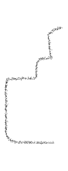

Cluster A : Neck sample 1-4 with 0.0 distance

Cluster B: PlayStation Joysticks, piece of art in sitting room, Half Drank Soda, T-shirt Saliva Stain

My Inference: He was died through strangulation. The neck samples are the same distance (0.0), hence they are probably the president DNA However, the T-shirt Saliva stain has the greatest distance of (0.70), hence this the Killer’s nucleotide sequence. There is possibility that they were other people in the room has there is a variation in the other sequences obtained. The Half Drank soda has a distance of 0.20, piece of art in the sitting room (0.18). The playstation joystick has a short distance 0.03, it is possible someone related to the deceased was present in the room or the deceased had used the playstation earlier before one of the killers picked it up.

DATASET: [Here](https://github.com/josoga2/sc_data/tree/main/forensics)

**Early Disease Epidemiology**

The governor of Osun state demands an emergency report from you about an infection that is rapidly spreading in the state. Interestingly, the situation started just after some boys tampered with one of the shrines in Ile-Ife. Everyone thinks it is the wrath of the gods, but the government thinks it is just a disease outbreak. Provide a simple epidemiological report detailing the nature of the disease, the most likely causal agent of the disease, and necessary measures to prevent further spread.

DATASET: [Here](https://github.com/josoga2/sc_data/tree/main/public_health)

[adewale.ogunleye@uni-wuerzburg.de](mailto:adewale.ogunleye@uni-wuerzburg.de)

[josoga2@gmail.com](mailto:josoga2@gmail.com)

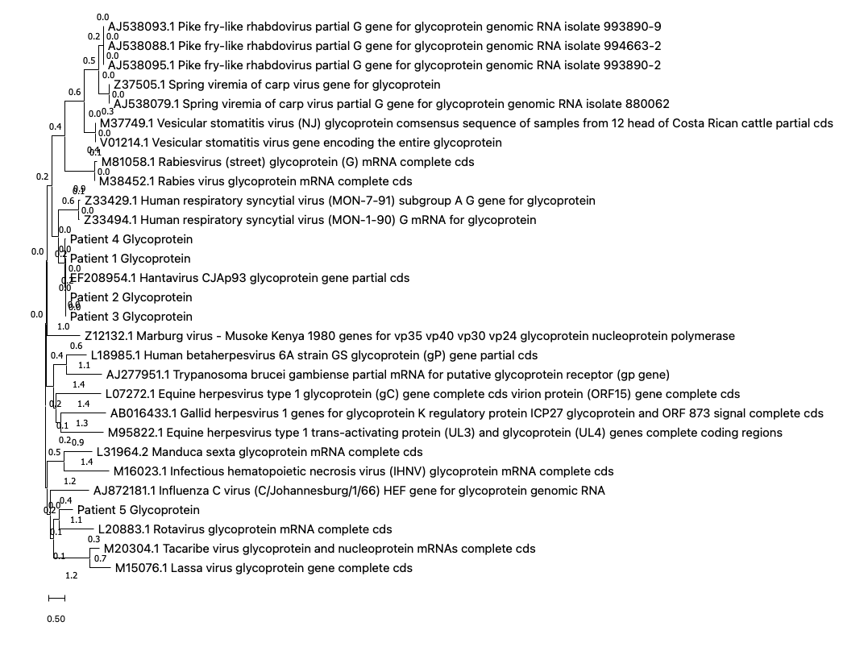

The DNA isolated from patient 1-4 belong is identical to the EF208954.1 Hantavirus CJAp93 glycoprotein gene partial CDs.

The infection affecting the village is “Hantavirus”, Hantavirus is a rodent-borne diseases. In Africa (Guinea), the virus was detected in wood mouse. It causes 2 life-threatening human zoonoses: Haemorrhagic fever with renal syndrome and pulmonary disease.

Since the boys tempered with the shrine, shrines are usually found in the focus and these rodents are domiciled within wood forest. Hence, they could have picked by inhaling the excreta of infected rodents. The diseases can be transmitted from human-human, hence why it is rapidly been transmitted across the village. The virus has no vaccine; However, it can be prevented and control within the village by practicing sanitary conditions:

* Disinfecting areas
* Stack woodpiles away from buildings
* Seal up holes inside and outside
* Quarantine infected persons to reduce transmission.